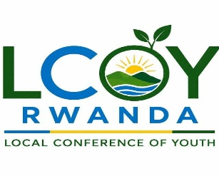
LCOY Rwanda 2026 – Concept Note

Local Conference of Youth on Climate Change

1. Executive Summary
LCOY Rwanda 2026 is the second Local Conference of Youth to be held in Rwanda, officially approved by the LCOY Working Group under YOUNGO, the Children and Youth Constituency of the UNFCCC. This youth-led initiative will take place over a full Climate Month from September 26 to October 30, 2026, reaching an estimated 3,500–5,000+ young Rwandans across all 30 districts and 4 provinces & Kigali city. The conference will produce a validated National Children & Youth Climate Position Paper submitted to the Ministry of Environment and YOUNGO's Global Youth Statement process. Key legacy outputs include 50,000 trees planted, 50 school environment clubs, 5 university chapters and a permanent Rwanda Youth Climate Coalition. A youth delegation will present the Position Paper at COP31 in Antalya, Turkey (November 9–20, 2026).

2. Background and Rationale
The Local Conference of Youth -LCOY is an official youth-led process under YOUNGO, the Children and Youth Constituency of the United Nations Framework Convention on Climate Change - UNFCCC. LCOYs are held in countries around the world to amplify youth voices, build capacity and feed national priorities into the Global Youth Statement presented at the annual Conference of Parties -COP. Since the first LCOY was held in 2013, over 50 countries have hosted LCOYs, creating a global movement of youth climate advocacy that directly influences international climate negotiations.
Rwanda has demonstrated strong political commitment to climate action through its Vision 2050, the Second National Strategy for Transformation, the Green Growth and Climate Resilience Strategy and its Nationally Determined Contributions- NDCs 3.0. The government has committed to reducing emissions by 38% by 2030 and achieving net-zero emissions by 2050. However, young Rwandans who represent 65% of the population face significant challenges, including a youth unemployment rate of 15.4% and limited access to decision-making spaces. While Rwanda has made progress in youth engagement through initiatives like the National Youth Council and youth-focused programs in agriculture and entrepreneurship, young people have historically lacked a structured, youth-led platform to engage with national climate processes. LCOY Rwanda 2026 fills this critical gap.
3. Goals and Objectives

Overall Goal: To empower young Rwandans to become active agents of climate action and influence national climate policy through a participatory, youth-led and inclusive conference process.
Specific Objectives:
# | Objective | Target
1 | Build youth capacity in climate advocacy and UNFCCC processes | 3,500–5,000+ youth trained
2 | Produce a validated National Children & Youth Climate Position Paper | 1 document submitted to YOUNGO and Government
3 | Strengthen youth networks across all provinces | Permanent Rwanda Youth Climate Coalition established
4 | Influence national policy (NDCs, NBSAP) | Position paper recommendations tracked
5 | Showcase youth-led climate solutions | 8-10 innovations pitched at National LCOY

4. Thematic Focus
LCOY Rwanda 2026 integrates the following thematic priorities:
1.Climate-Resilient Agriculture & Food Systems: Climate-smart practices, agroecology, youth agripreneurship, nutrition and food security. This theme addresses the impact of climate change on Rwanda's agricultural sector, which employs approximately 70% of the population.
2.Biodiversity Conservation & Ecosystem Restoration: Nature-based solutions, forest landscape restoration, alignment with the Kunming-Montreal Global Biodiversity Framework and protection of Rwanda's unique ecosystems including Nyungwe, Volcanoes and Akagera national parks.
4.Just Energy Transition & Green Jobs: Renewable energy access, circular economy, green employment pathways and energy efficiency. This theme aligns with Rwanda's goal of universal electricity access by 2030.
5.Loss & Damage + Climate Mobility: Disaster risk reduction, climate finance access, refugees and forced migration. This theme addresses the human cost of climate change and the need for justice and compensation for affected communities.
6.Gender Justice, Disability Inclusion & Just Transition: Women's climate leadership, empowerment and gender-responsive climate action. Women are disproportionately affected by climate change and must be at the center of solutions. This theme also centers the inclusion of persons with disabilities ensuring that climate policies and programs are accessible, responsive and equitable for all, including youth and adults with disabilities who are often overlooked in climate planning. The theme promotes intersectional approaches that recognize how gender, disability and other identities shape climate vulnerability and resilience.
7.Action for Climate Empowerment (ACE): Climate education, awareness, public participation and access to information. This theme aligns with UNFCCC Article 6 and the Glasgow work programme on ACE.
8.Technology, Innovation & Digital Climate Action: Artificial Intelligence (AI), Internet of Things (IoT), e-waste management, digital tools for climate action and biotechnology.
9.Arts & Culture for Climate: Music, poetry, dance, drama, murals, waste-to-art, ceramics and storytelling as vehicles for climate communication and healing.
Note: Technology serves as both a standalone theme and cross-cutting across all other thematic areas.

4.1Thematic Competitions Framework
The LCOY Rwanda 2026 Thematic Competitions Framework represents a transformative approach to youth engagement in climate action, shifting the paradigm from passive participation to active solution-building. This flagship initiative recognizes that young Rwandans who constitute 65% of the population possess immense creativity, technical skills and local knowledge that remain underutilized in addressing climate challenges. By providing structured platforms for innovation, the competitions bridge the critical gap between youth potential and tangible climate action.
Across the eight thematic priorities Climate-Resilient Agriculture, Biodiversity Conservation, Just Energy Transition, Loss & Damage, Gender Justice, Disability Inclusion & Just Transition, Action for Climate Empowerment, Technology Innovation and Arts & Culture the competitions feature four distinct participation categories: Youth Innovators, Small and Medium Enterprises (SMEs), Persons with Disabilities and Students (primary, secondary and university levels). This multi-category approach ensures inclusive participation across diverse youth populations and abilities.
The framework culminates in a Grand Innovation Challenge where the winner receives Awards and incubation support. Competition outputs will directly inform the National Children & Youth Climate Position Paper, feed into the Rwanda Youth Climate Coalition and contribute to the lasting legacy of 50 school environment clubs, 5 university chapters and 50,000 trees planted nationwide.
Through this framework, LCOY Rwanda 2026 ensures that youth are not merely consulted but recognized as essential architects of Rwanda's climate resilience and green economy transition.
5. Programme Structure

5.1 Climate Month Overview (September 26 – October 30, 2026)
LCOY Rwanda 2026 is structured across five phases over a full Climate Month:
Phase | Dates | Location | Youth Reach
Umuganda Launch | September 26 | Nationwide (30 districts) | Nationwide
District Dialogues | September 27 – October 26 | 30 districts | 2,100–3,000
Provincial Consultations | October 19–23 | 4 provinces | 800–1,200
Statement Consolidation | October 9–27 | Virtual + Kigali | 15-20 (drafting team)
National LCOY Main Event | October 28–30 | Kigali | 600–800
Total Direct Reach |  |  | 3,500–5,000+

5.2 Provincial Consultations
Province | Date | Host Location | Theme
Eastern | October 20 | UR Nyagatare | Climate-Resilient Agriculture & Farmer-Led Solutions
Southern | October 21 | UR Huye | Traditional Knowledge & School Outreach
Northern | October 22 | UR Musanze | Agroecology & Youth-Led Restoration
Western | October 23 | IPRC Karongi | Lake Kivu Ecosystem, Climate Mobility & Technology

5.3 National LCOY Main Event (October 28–30, 2026)
Day 1 (October 28) – Knowledge, Dialogue & Arts: Opening Plenary featuring high-level panel with Ministry of Environment, Rwanda Green Fund and youth advocates. World Cafe Thematic Labs (7 stations) on Agriculture, Biodiversity, Energy, Loss & Damage, Gender, ACE and Technology. Young Leaders Session featuring emerging leaders from Rwanda and other nationalities. Nuclear Energy Session exploring low-carbon energy options. Children & Youth Track with age-appropriate activities (ages 6-10, 11-14, 15-17). Arts for Climate performances and Networking Reception.
Day 2 (October 29) – Action, Policy & Pitching: Foresight Workshop (Horizon Scanning) identifying emerging climate trends. Climate Innovation Pitching Event featuring 8-10 youth innovators pitching solutions. Food System Sessions (Climate Resilience and Investment & Agrifinance). Climate Resilient Seed Session with seed exploration and planting demonstration. Biodiversity Conservation and Ecosystem Restoration sessions. Policy Lab drafting the National Children & Youth Climate Position Paper. Closing Plenary with live voting on Position Paper recommendations.
Day 3 (October 30) – Culture, Heritage & Global Solidarity: Cultural & Heritage Event featuring different nationalities showcasing cultural expressions of climate action. World Cafe: Culture, Heritage & Climate exploring traditional knowledge and arts. Thematic Cultural Sessions on Storytelling, Music & Poetry, Traditional Knowledge and Visual Arts. Arts for Climate Grand Performance with combined youth choir and traditional dance. Closing Plenary and Networking Reception & Mural Unveiling.

6. Governance and Organizing Structure

6.1 Lead Organizer
World Food Forum Rwanda Chapter serves as the Lead Co-Organizer, responsible for overall coordination, governance, accountability to the LCOY Working Group and primary liaison with YOUNGO.

6.2 Co-Organizing Partners

Hope for Future Development, Forest for Life, Agirite, GanzAfrica, RYAF, Green Sugira Organization, Conservation Leaders Network, Impanuro Girls Initiative, UNILAK TERRA CARE ENVIRONMENTAL CLUB, Rwanda Young Generation in Nuclear.

7. Key Outputs and Legacy
Output | Description | Deadline
National Children & Youth Climate Position Paper | Validated by youth delegates, submitted to Ministry of Environment, MINAGRI, REMA and YOUNGO/UNFCCC | October 29, 2026
COP31 Presentation | Position Paper presented by Rwanda youth delegation in Antalya, Turkey | November 9–20, 2026
50,000 Trees Planted | Nationwide across 30 districts, monitored for survival rates | September 2026 – March 2027
50 School Environment Clubs | Pilot clubs (10 per province), activity toolkit, leader training | February 2027
5 University Chapters | One per province at UR Nyagatare, UR Huye, UR Musanze, IPRC Karongi, Kigali campus | January 2027
Rwanda Youth Climate Coalition | Permanent youth governing body with annual assembly | March 2027
Post-LCOY Impact Report | Comprehensive report for donors and LCOY Working Group | December 31, 2026

8. Contact Information General Inquiries:

lcoyrwanda2026@kigaliclimateactionweek.org or rwalcoy2026@worldfoodforumrwanda.org

Prepared by: WFF Rwanda Chapter (Lead Co-Organizer)
In partnership with Co-organizers
LCOY Rwanda 2026 – Youth-led, participatory and inclusive. Our Climate, Our Future, Our Rwanda.
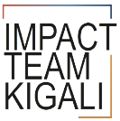
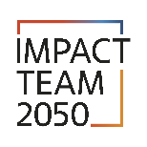
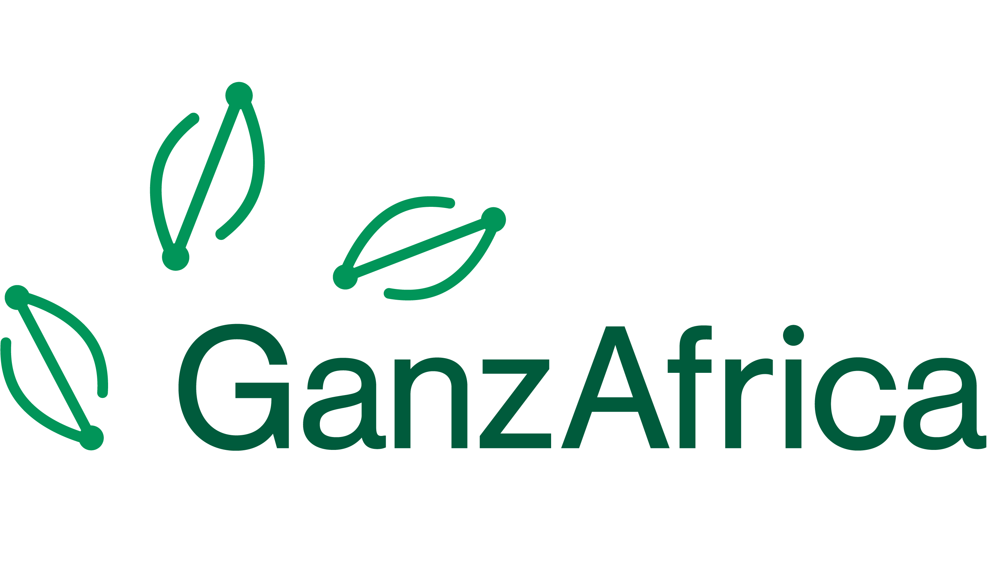
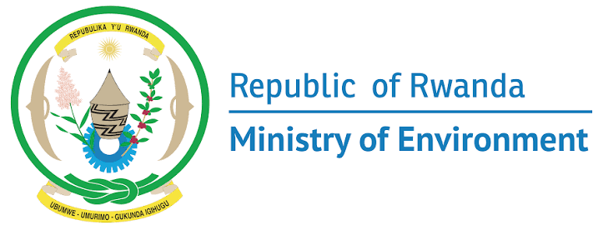
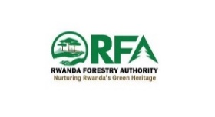
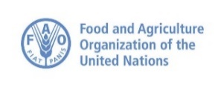
Partners

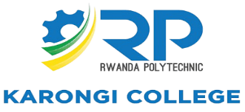

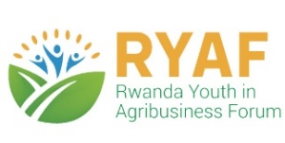
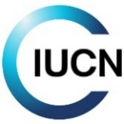
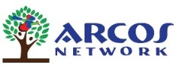

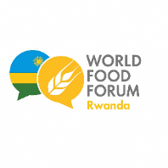
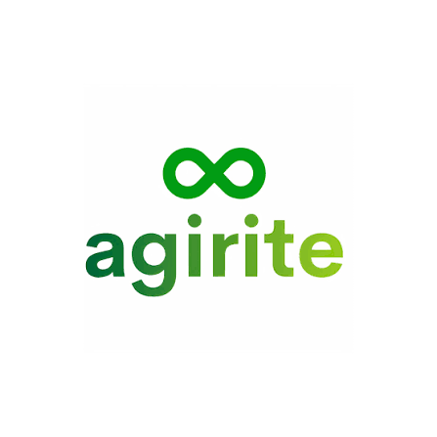

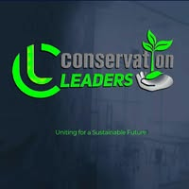
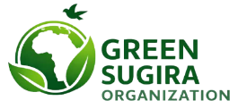
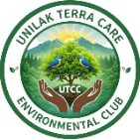

Organizers

